**ESC113 Term Project**

**VARIATION IN TEMPERATURES IN SERIES OF TANKS**

**TEAM** :-

* Madhav Lata (220597) - Umang Garg (221156)
* Avinash Kumar (220256) - Harsh Nirmal (220431)
* Mehek Agarwal (220646) - Vardaan Vig (221170)
* Kavita (220512) - Satyam Kumar(220983)

- Vyom Pratap Singh (221211)

**INTRODUCTION** :- Complex Heat Transfer problems require a deep understanding of fundamental principles, mathematical modeling, and problem-solving techniques. Solving such problem makes a real-world impact as it contributes to sustainability and also drive innovation.

We focus on the development of a program that determines the steady state temperature for a series of tanks with a unique heat transfer mechanism. The tanks receive oil at a constant flow rate and incorporate a system where saturated steam condenses in serpentines inside each tank. The temperature within the tanks is kept uniform through mixing, and the temperature of the exiting oil represents the tank's temperature. So for a specific tank, the heat transfer rate from the steam coil to the fuel is :-



where UA is the product of the heat transfer coefficient and the area of the coil for each tank, T = temperature of the oil in the tank, and Q = rate of heat transferred in kJ/min.

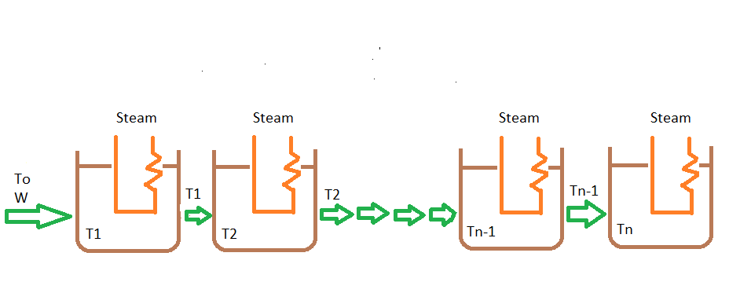

So We will determine the steady state Temperature in all three tanks.

**RESULT** :-

* Energy balance can be made on each of the individual tanks. For the first tank, the energy balance can be expressed by :-

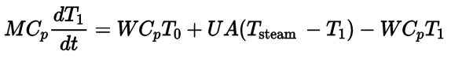

* Similarly for any ith tank, we can replace T1 by Ti and To by Ti-1 and hence we have system of n first-order ODEs
* 
* We have used the **Explicit Euler’s method** to solve the first-order system of ODEs.
* We took a time-step(h) of 0.5 seconds and tolerance of 0.1 degree Celsius for convergence of solution. We came down to h=0.5 after trying h as low as 0.1 and finding out that final solution has not much changed but time taken in calculation had increased a lot. For example:-

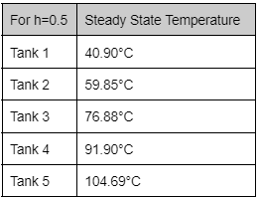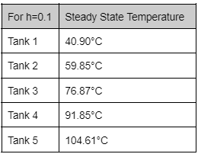

* We calculated Steady State Time (the time system will take to reach steady state) by multiplying time step with number of iterations it took rendering us the total time.
* The program also has two plots .Figure 1 shows the convergence of the values of Temperatures and achieving a steady state. It’s the plot of how much T changes in each tank on each iteration. We observed that delta_T has gone to 0 in Tank 1 much earlier than Tank n, and it justifies how the final temperature is successively increasing in further tanks.
* Figure 2 shows values of Temperatures with time, so it signifies how temperatures change with time.
* Also, we made a matrix of T_values showing us Temp values after each time step .

**CONCLUSION:-**

* As the initial and steam temperature values at start are increased, the final values of steady-state temperatures also increase in all the tanks.
* By using different numbers of tanks for the same To and Tsteam, what we found is that the Temperature of the initial tanks varies very little concerning number of tank like for To=20°C and Tsteam=250°C following are values for 5 Tanks and 3 Tanks :-

|  |  |
| --- | --- |
| Tank 1 | 40.90°C |
| Tank 2 | 59.85°C |
| Tank 3 | 76.88°C |
| Tank 4 | 91.90°C |
| Tank 5 | 104.69°C |

|  |  |
| --- | --- |
| Tank 1 | 40.82°C |
| Tank 2 | 59.29°C |
| Tank 3 | 74.94°C |

Hence, there is very small change in steady state temperature of tank 1,2 and 3.

* Steady state Time is independent of whatever h value or max_iterations value we may take.
* The value of h and max_iterations are complementary as for lower values of h we will need more iterations for the temperatures to converge. If values are not changed accordingly, it will have an impact on the accuracy of the final answer. Example :- For n=5, To=20°C and Tsteam=250°C , if we take h=0.5 it converges in 286 iterations but for h=0.1 it takes 1430 iterations so taking max_iteration = 1000 will not work in second case.